**Bug on Page ‘my.bonify.de’:**

**Issues 5:** On '**https://my.bonify.de/login?next=/**' Page, instead of 'E-mail (username' it should display either ‘Email’ or ‘UserName’ field.

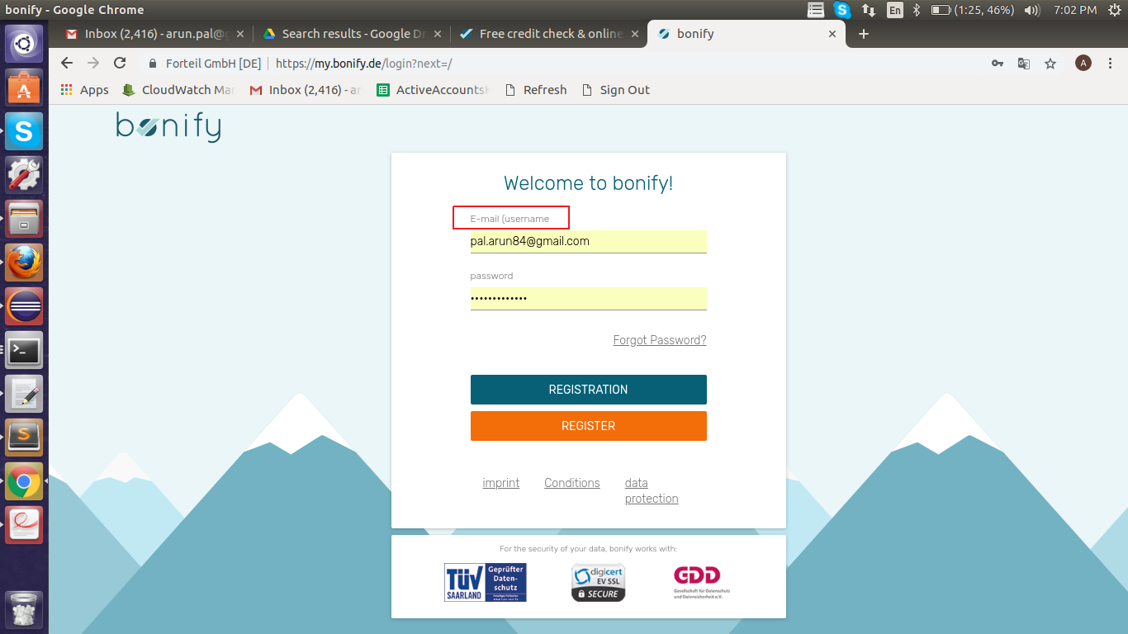

**Steps To Reproduce:**

1: Start Chrome Browser with url **‘https://my.bonify.de/login/’.**

2: Observe First Field.

**Expected Result:** Login page should display either ‘Email’ or ‘Username’ field.

**Actual Result:** Login page displaying ‘E-mail (username'.

**Browser:** Chrome (Version 70)

**OS:** Ubuntu (16)

**Priority:** P3

**Assign To :** Developer.